2. Online Hotel Room Booking System
Aim
To design and develop an online hotel room booking system that enables users to search for hotels, check room availability, view room details and prices, book rooms, make payments, and manage reservations. The administrator can manage room availability, prices, bookings, and website information.
Algorithm
- Start the application.
- Display the home page with hotel and room details.
- Allow users to register, log in, and manage their profiles.
- Enable users to search for hotels based on destination, dates, and number of guests.
- Display available rooms, prices, amenities, and reviews.
- Allow users to select a room and enter booking details.
- Check room availability for the selected dates.
- Process the payment and confirm the reservation.
- Allow users to view booking history and modify or cancel bookings at least three days before arrival.
- Allow the administrator to update room prices, quantities, and booking details.
- Allow the administrator to manage website pages and customer service information.
- Stop

Code :.
<!DOCTYPE html>
<html lang="en">
<head>
<meta charset="UTF-8">
<meta name="viewport" content="width=device-width, initial-scale=1.0">

<title>Online Hotel Room Booking System</title>

<style>

* {
box-sizing: border-box;
margin: 0;
padding: 0;
font-family: Arial, sans-serif;
}

body {
background: #f5f6fa;
color: #222;
}

/* HEADER */

header {
background: #263238;
color: white;
padding: 18px 40px;
display: flex;
justify-content: space-between;
align-items: center;
}

header h1 {
font-size: 24px;
}

nav button {
background: none;
border: none;
color: white;
padding: 8px 10px;
margin: 3px;
cursor: pointer;
}

nav button:hover {
background: #455a64;
border-radius: 5px;
}

/* MAIN */

.container {
width: 90%;
max-width: 1200px;
margin: 30px auto;
}

.section {
display: none;
}

.active {
display: block;
}

/* HOME */

.hero {
background: #607d8b;
color: white;
padding: 70px 30px;
text-align: center;
border-radius: 10px;
}

.hero h2 {
font-size: 38px;
margin-bottom: 15px;
}

.hero p {
font-size: 18px;
margin-bottom: 25px;
}

/* SEARCH */

.search-box {
background: white;
padding: 25px;
border-radius: 10px;
margin-top: 25px;
box-shadow: 0 2px 8px #ccc;
}

.search-box input,
.search-box select {
width: 22%;
padding: 12px;
margin: 5px;
}

/* BUTTON */

.action {
background: #37474f;
color: white;
border: none;
padding: 11px 18px;
border-radius: 5px;
cursor: pointer;
}

.action:hover {
background: #546e7a;
}

/* CARDS */

.card-container {
display: flex;
gap: 20px;
flex-wrap: wrap;
margin-top: 25px;
}

.card {
background: white;
padding: 25px;
border-radius: 10px;
box-shadow: 0 2px 8px #ccc;
flex: 1;
min-width: 220px;
}

.card h3 {
margin-bottom: 10px;
}

/* ROOMS */

.rooms {
display: flex;
gap: 20px;
flex-wrap: wrap;
margin-top: 20px;
}

.room {
background: white;
width: 270px;
border-radius: 10px;
overflow: hidden;
box-shadow: 0 2px 8px #ccc;
}

.room .image {
height: 150px;
background: #90a4ae;
display: flex;
justify-content: center;
align-items: center;
color: white;
font-size: 45px;
}

.room-content {
padding: 20px;
}

.room-content h3 {
margin-bottom: 10px;
}

.price {
font-size: 20px;
font-weight: bold;
margin: 10px 0;
}

/* FORM */

.form-box {
background: white;
max-width: 650px;
margin: auto;
padding: 25px;
border-radius: 10px;
box-shadow: 0 2px 8px #ccc;
}

.form-box h2 {
margin-bottom: 20px;
}

.form-box input,
.form-box select,
.form-box textarea {
width: 100%;
padding: 11px;
margin: 8px 0 15px;
border: 1px solid #bbb;
border-radius: 5px;
}

/* TABLE */

table {
width: 100%;
border-collapse: collapse;
margin-top: 20px;
background: white;
}

th,
td {
border: 1px solid #ddd;
padding: 12px;
text-align: center;
}

th {
background: #37474f;
color: white;
}

/* FOOTER */

footer {
margin-top: 50px;
background: #263238;
color: white;
text-align: center;
padding: 20px;
}

/* MOBILE */

@media(max-width: 768px) {

header {
flex-direction: column;
gap: 15px;
}

.search-box input,
.search-box select {
width: 100%;
margin: 5px 0;
}

.room {
width: 100%;
}
}

</style>
</head>

<body>

<!-- HEADER -->

<header>

<h1>🏨 Hotel Booking System</h1>

<nav>

<button onclick="showSection('home')">Home</button>

<button onclick="showSection('rooms')">Rooms</button>

<button onclick="showSection('booking')">Book Room</button>

<button onclick="showSection('myBookings')">
My Bookings
</button>

<button onclick="showSection('profile')">
Profile
</button>

<button onclick="showSection('login')">
Login
</button>

<button onclick="showSection('register')">
Register
</button>

<button onclick="showSection('admin')">
Admin
</button>

<button onclick="showSection('contact')">
Contact
</button>

</nav>

</header>

<div class="container">

<!-- HOME -->

<section id="home" class="section active">

<div class="hero">

<h2>Welcome to Our Hotel</h2>

<p>
Find and book your perfect room easily.
</p>

<button class="action"
onclick="showSection('rooms')">

View Rooms

</button>

</div>

<div class="search-box">

<h2>🔍 Search Hotel Rooms</h2>

<br>

<input
type="text"
id="destination"
placeholder="Destination">

<input
type="date"
id="checkin">

<input
type="date"
id="checkout">

<select id="guests">

<option value="">Guests</option>

<option>1 Guest</option>

<option>2 Guests</option>

<option>3 Guests</option>

<option>4 Guests</option>

</select>

<button
class="action"
onclick="searchRooms()">

Search

</button>

</div>

<div class="card-container">

<div class="card">

<h3>🛏️ Comfortable Rooms</h3>

<p>
Choose from single, double, deluxe and suite rooms.
</p>

</div>

<div class="card">

<h3>💳 Easy Booking</h3>

<p>
Book your room quickly using our online system.
</p>

</div>

<div class="card">

<h3>📅 Flexible Booking</h3>

<p>
View and manage your booking history.
</p>

</div>

<div class="card">

<h3>⭐ Customer Reviews</h3>

<p>
View hotel and room reviews.
</p>

</div>

</div>

</section>

<!-- ROOMS -->

<section id="rooms" class="section">

<h2>🛏️ Available Rooms</h2>

<div class="rooms">

<!-- SINGLE -->

<div class="room">

<div class="image">
🛏️
</div>

<div class="room-content">

<h3>Single Room</h3>

<p>
Suitable for one person.
</p>

<p>
Free Wi-Fi | TV | Breakfast
</p>

<div class="price">
₹2,000 / night
</div>

<button
class="action"
onclick="selectRoom('Single Room',2000)">

Book Now

</button>

</div>

</div>

<!-- DOUBLE -->

<div class="room">

<div class="image">
🛏️
</div>

<div class="room-content">

<h3>Double Room</h3>

<p>
Comfortable room for two people.
</p>

<p>
Free Wi-Fi | TV | Breakfast
</p>

<div class="price">
₹3,500 / night
</div>

<button
class="action"
onclick="selectRoom('Double Room',3500)">

Book Now

</button>

</div>

</div>

<!-- DELUXE -->

<div class="room">

<div class="image">
🏨
</div>

<div class="room-content">

<h3>Deluxe Room</h3>

<p>
Spacious premium room.
</p>

<p>
Wi-Fi | TV | Breakfast | AC
</p>

<div class="price">
₹5,000 / night
</div>

<button
class="action"
onclick="selectRoom('Deluxe Room',5000)">

Book Now

</button>

</div>

</div>

<!-- SUITE -->

<div class="room">

<div class="image">
🏰
</div>

<div class="room-content">

<h3>Suite Room</h3>

<p>
Luxury room with premium facilities.
</p>

<p>
Wi-Fi | TV | AC | Breakfast
</p>

<div class="price">
₹7,500 / night
</div>

<button
class="action"
onclick="selectRoom('Suite Room',7500)">

Book Now

</button>

</div>

</div>

</div>

</section>

<!-- BOOKING -->

<section id="booking" class="section">

<div class="form-box">

<h2>📝 Book Your Room</h2>

<label>Guest Name</label>

<input
type="text"
id="guestName"
placeholder="Enter your name">

<label>Email</label>

<input
type="email"
id="guestEmail"
placeholder="Enter email">

<label>Phone</label>

<input
type="text"
id="guestPhone"
placeholder="Enter phone number">

<label>Room Type</label>

<select id="roomType">

<option value="">
Select Room
</option>

<option value="Single Room">
Single Room - ₹2,000
</option>

<option value="Double Room">
Double Room - ₹3,500
</option>

<option value="Deluxe Room">
Deluxe Room - ₹5,000
</option>

<option value="Suite Room">
Suite Room - ₹7,500
</option>

</select>

<label>Check-in Date</label>

<input
type="date"
id="bookCheckin">

<label>Check-out Date</label>

<input
type="date"
id="bookCheckout">

<label>Number of Guests</label>

<select id="bookGuests">

<option>1</option>

<option>2</option>

<option>3</option>

<option>4</option>

</select>

<label>Payment Method</label>

<select id="payment">

<option>Credit Card</option>

<option>Debit Card</option>

<option>UPI</option>

<option>Cash</option>

</select>

<br><br>

<button
class="action"
onclick="bookRoom()">

Confirm Booking

</button>

</div>

</section>

<!-- MY BOOKINGS -->

<section id="myBookings" class="section">

<h2>📅 My Bookings</h2>

<table id="bookingTable">

<tr>

<th>Guest</th>

<th>Room</th>

<th>Check-in</th>

<th>Check-out</th>

<th>Status</th>

<th>Action</th>

</tr>

<tr>

<td>Demo User</td>

<td>Deluxe Room</td>

<td>10-10-2026</td>

<td>12-10-2026</td>

<td>Confirmed</td>

<td>

<button
class="action"
onclick="modifyBooking()">

Modify

</button>

<button
class="action"
onclick="cancelBooking(this)">

Cancel

</button>

</td>

</tr>

</table>

</section>

<!-- PROFILE -->

<section id="profile" class="section">

<div class="form-box">

<h2>👤 My Profile</h2>

<label>Full Name</label>

<input
type="text"
value="Demo User">

<label>Email</label>

<input
type="email"
value="demo@gmail.com">

<label>Phone</label>

<input
type="text"
value="9876543210">

<label>Address</label>

<textarea rows="4">
India
</textarea>

<button
class="action"
onclick="updateProfile()">

Update Profile

</button>

</div>

</section>

<!-- LOGIN -->

<section id="login" class="section">

<div class="form-box">

<h2>🔐 Login</h2>

<label>Email</label>

<input
type="email"
id="loginEmail"
placeholder="Enter email">

<label>Password</label>

<input
type="password"
id="loginPassword"
placeholder="Enter password">

<button
class="action"
onclick="login()">

Login

</button>

</div>

</section>

<!-- REGISTER -->

<section id="register" class="section">

<div class="form-box">

<h2>📝 Create Account</h2>

<label>Full Name</label>

<input
type="text"
id="regName"
placeholder="Enter full name">

<label>Email</label>

<input
type="email"
id="regEmail"
placeholder="Enter email">

<label>Phone</label>

<input
type="text"
id="regPhone"
placeholder="Enter phone">

<label>Password</label>

<input
type="password"
id="regPassword"
placeholder="Create password">

<button
class="action"
onclick="register()">

Register

</button>

</div>

</section>

<!-- ADMIN -->

<section id="admin" class="section">

<h2>👨‍💼 Admin Dashboard</h2>

<div class="card-container">

<div class="card">

<h3>Total Rooms</h3>

<p>50</p>

</div>

<div class="card">

<h3>Available Rooms</h3>

<p>35</p>

</div>

<div class="card">

<h3>Total Bookings</h3>

<p>120</p>

</div>

<div class="card">

<h3>Users</h3>

<p>200</p>

</div>

</div>

<h3 style="margin-top:30px;">
Manage Rooms
</h3>

<table>

<tr>

<th>Room Type</th>

<th>Quantity</th>

<th>Price</th>

<th>Action</th>

</tr>

<tr>

<td>Single Room</td>

<td>15</td>

<td>₹2,000</td>

<td>

<button
class="action"
onclick="editRoom()">

Edit

</button>

</td>

</tr>

<tr>

<td>Double Room</td>

<td>15</td>

<td>₹3,500</td>

<td>

<button
class="action"
onclick="editRoom()">

Edit

</button>

</td>

</tr>

<tr>

<td>Deluxe Room</td>

<td>10</td>

<td>₹5,000</td>

<td>

<button
class="action"
onclick="editRoom()">

Edit

</button>

</td>

</tr>

<tr>

<td>Suite Room</td>

<td>10</td>

<td>₹7,500</td>

<td>

<button
class="action"
onclick="editRoom()">

Edit

</button>

</td>

</tr>

</table>

</section>

<!-- FAQ -->

<section id="faq" class="section">

<div class="form-box">

<h2>❓ Frequently Asked Questions</h2>

<br>

<h3>How can I book a room?</h3>

<p>
Select a room, enter your details and confirm the booking.
</p>

<br>

<h3>Can I cancel my booking?</h3>

<p>
Yes. Bookings can be cancelled according to hotel policy.
</p>

<br>

<h3>Can I modify my booking?</h3>

<p>
Yes. You can modify the booking before the allowed cancellation period.
</p>

<br>

<h3>What payment methods are supported?</h3>

<p>
Credit Card, Debit Card, UPI and Cash.
</p>

</div>

</section>

<!-- TRAVEL GUIDE -->

<section id="travel" class="section">

<div class="form-box">

<h2>🗺️ Local Travel Guide</h2>

<br>

<h3>Tourist Places</h3>

<p>
Visit nearby tourist attractions, restaurants,
shopping areas and transportation facilities.
</p>

<br>

<h3>Transportation</h3>

<p>
Taxi, bus, train and airport transportation
are available near the hotel.
</p>

</div>

</section>

<!-- CONTACT -->

<section id="contact" class="section">

<div class="form-box">

<h2>📞 Contact Us</h2>

<label>Name</label>

<input
type="text"
id="contactName"
placeholder="Your name">

<label>Email</label>

<input
type="email"
id="contactEmail"
placeholder="Your email">

<label>Message</label>

<textarea
id="contactMessage"
rows="5"
placeholder="Your message"></textarea>

<button
class="action"
onclick="sendMessage()">

Send Message

</button>

</div>

</section>

<!-- PRIVACY -->

<section id="privacy" class="section">

<div class="form-box">

<h2>🔒 Privacy Policy</h2>

<p>
We collect basic user information required
for hotel booking and account management.
</p>

<br>

<p>
User information should be protected and
should not be shared without permission.
</p>

</div>

</section>

</div>

<!-- FOOTER -->

<footer>

<p>
© 2026 Online Hotel Room Booking System
</p>

</footer>

<script>

/* SHOW SECTION */

function showSection(id) {

let sections =
document.querySelectorAll(".section");

sections.forEach(function(section) {

section.classList.remove("active");

});

document
.getElementById(id)
.classList.add("active");

window.scrollTo(0,0);
}

/* SEARCH ROOMS */

function searchRooms() {

let destination =
document.getElementById("destination").value;

let checkin =
document.getElementById("checkin").value;

let checkout =
document.getElementById("checkout").value;

let guests =
document.getElementById("guests").value;

if(destination === "" ||
checkin === "" ||
checkout === "" ||
guests === "") {

alert("Please enter all search details.");

return;
}

alert(
"Searching rooms in " +
destination
);

showSection("rooms");
}

/* SELECT ROOM */

function selectRoom(room, price) {

document.getElementById("roomType").value = room;

showSection("booking");

}

/* BOOK ROOM */

function bookRoom() {

let name =
document.getElementById("guestName").value;

let email =
document.getElementById("guestEmail").value;

let phone =
document.getElementById("guestPhone").value;

let room =
document.getElementById("roomType").value;

let checkin =
document.getElementById("bookCheckin").value;

let checkout =
document.getElementById("bookCheckout").value;

if(name === "" ||
email === "" ||
phone === "" ||
room === "" ||
checkin === "" ||
checkout === "") {

alert("Please fill all booking details.");

return;
}

alert(
"Booking confirmed successfully!\n\n" +
"Guest: " + name +
"\nRoom: " + room +
"\nCheck-in: " + checkin +
"\nCheck-out: " + checkout
);

showSection("myBookings");

}

/* LOGIN */

function login() {

let email =
document.getElementById("loginEmail").value;

let password =
document.getElementById("loginPassword").value;

if(email === "" || password === "") {

alert("Please enter email and password.");

return;
}

alert("Login successful!");

showSection("home");

}

/* REGISTER */

function register() {

let name =
document.getElementById("regName").value;

let email =
document.getElementById("regEmail").value;

let phone =
document.getElementById("regPhone").value;

let password =
document.getElementById("regPassword").value;

if(name === "" ||
email === "" ||
phone === "" ||
password === "") {

alert("Please fill all fields.");

return;
}

alert("Registration successful!");

showSection("login");

}

/* MODIFY BOOKING */

function modifyBooking() {

alert(
"Booking modification page opened.\n" +
"You can change the booking details."
);

}

/* CANCEL BOOKING */

function cancelBooking(button) {

let confirmCancel =
confirm("Are you sure you want to cancel?");

if(confirmCancel) {

button
.parentElement
.parentElement
.remove();

alert("Booking cancelled successfully.");

}

}

/* PROFILE */

function updateProfile() {

alert("Profile updated successfully!");

}

/* ADMIN */

function editRoom() {

let price =
prompt("Enter new room price:");

if(price) {

alert(
"Room price updated to ₹" +
price
);

}

}

/* CONTACT */

function sendMessage() {

let name =
document.getElementById("contactName").value;

let email =
document.getElementById("contactEmail").value;

let message =
document.getElementById("contactMessage").value;

if(name === "" ||
email === "" ||
message === "") {

alert("Please fill all fields.");

return;
}

alert(
"Your message has been sent successfully!"
);

}

</script>

</body>
</html>
Outputs:

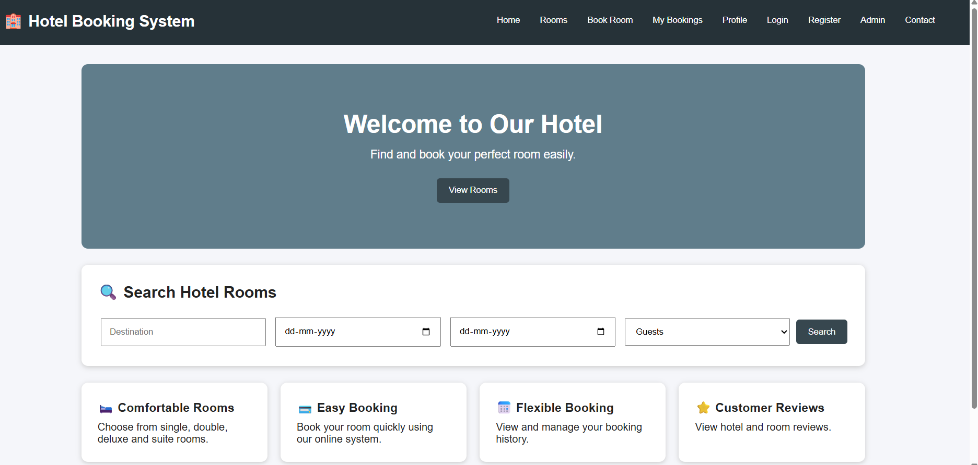
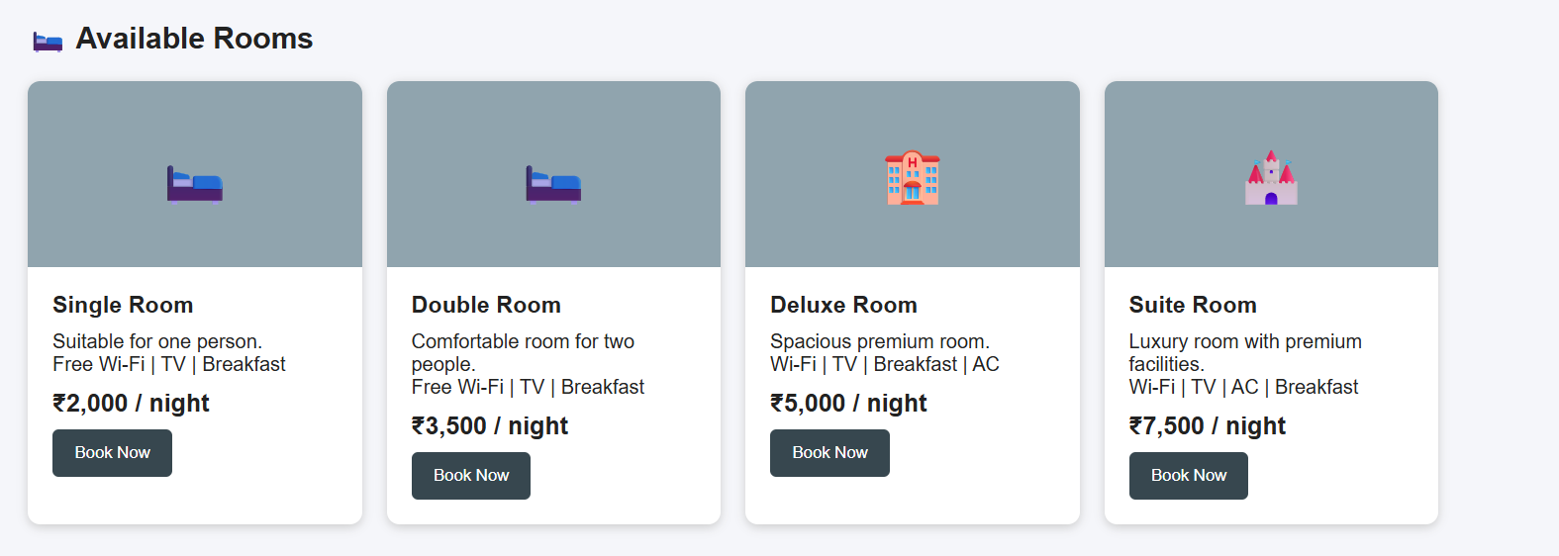
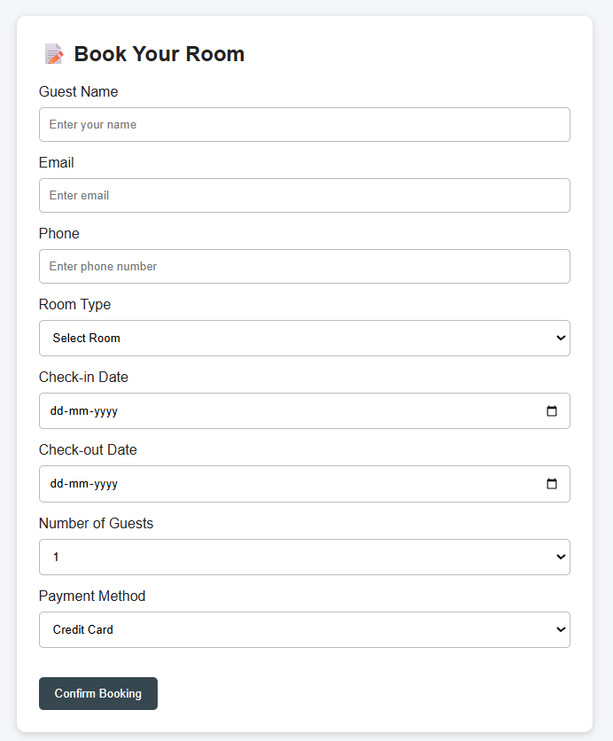
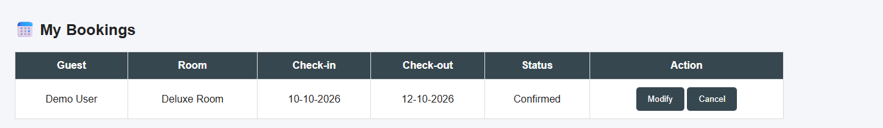
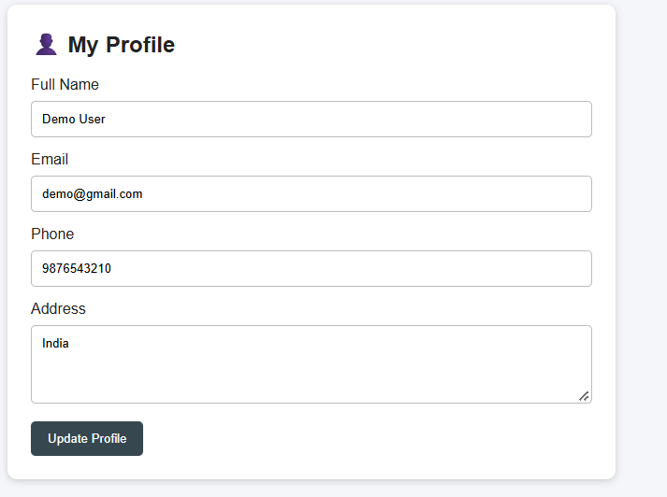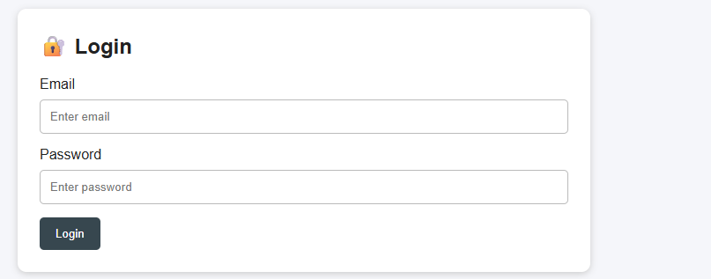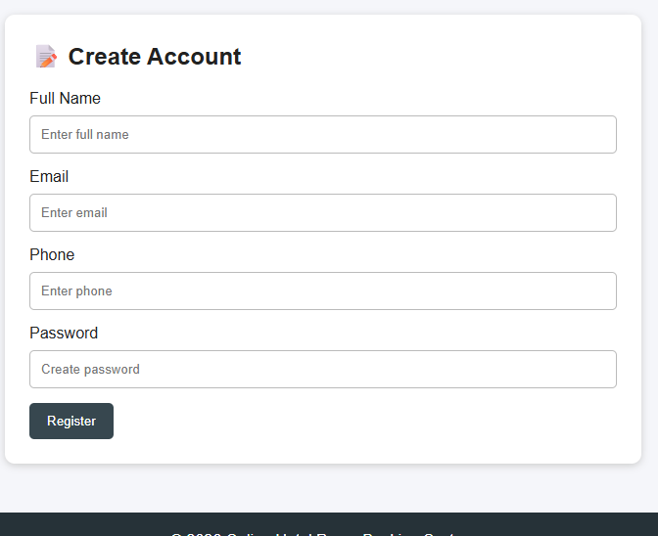

Result : Online Hotel Room Booking System successfully designed

